ENTREPRENEURSHIP
SEMESTER PROJECT REPORT
RidePool
Share Rides. Save Money. Go Together.
Team Members:
Hoor UN Ain (55835)
Areesha Raheel (55039)
Course: Entrepreneurship
Instructor: Tabinda Ali Shah Zaman
Semester: BSIT-6

1. Executive Summary

Business Concept
RidePool is a peer-to-peer ridesharing mobile/web platform built specifically for the Pakistani market, allowing commuters travelling similar routes to share a single vehicle and split the fare transparently based on the exact distance each passenger travels. Unlike conventional ride-hailing apps such as Uber or Yango, which charge each rider the full individual trip cost, RidePool's core innovation is its split-and-share fare engine: a single baseline fare is calculated for the vehicle's journey and then divided fairly among matched passengers according to distance covered, current fuel price, and a small platform margin.
The problem being solved is twofold and rooted directly in Pakistan's current economic reality: (1) the rapidly escalating cost of solo commuting caused by frequent fuel price hikes, and (2) the inefficiency and environmental cost of mostly-empty private vehicles and rickshaws making duplicate trips along the same corridors during peak hours. The target market is students and working professionals in urban centers such as Lahore who travel fixed daily routes (university, office, home) and are highly price-sensitive.

Mission Statement
To make everyday commuting affordable, transparent, and efficient for Pakistanis by enabling fair, fuel-cost-based ride sharing.

Vision Statement
Within 3-5 years, RidePool aims to become the leading cost-sharing mobility platform in Pakistan's major cities, reducing urban fuel consumption and traffic congestion while saving commuters a measurable share of their monthly transport budget.

Unique Selling Proposition (USP)
RidePool is the only ridesharing solution in Pakistan that combines a transparent, distance-proportional fare-split calculator with a manually adjustable fuel-price input (to reflect Pakistan's frequently fluctuating fuel rates) and full passenger control over who they share a ride with — all wrapped in a localized experience with Pakistani payment methods (Cash, JazzCash, EasyPaisa, Bank Transfer) and routes.

2. Scope and Feature Listing
RidePool's scope is deliberately focused on solving the cost-of-commute problem through fair fare-splitting rather than competing on the broader ride-hailing feature set. The platform covers trip setup, passenger matching, live tracking, and a transparent payment/receipt flow.

Core Features
Feature | Description | Priority
Distance-based fare splitting | Calculates each passenger's exact share of the baseline fare according to the distance they personally travelled, not a flat equal split. | Must Have
Adjustable fuel price input | Lets the fare engine reflect Pakistan's daily-fluctuating fuel prices by allowing manual entry/update of fuel cost per liter. | Must Have
Smart vehicle capacity matching | Dynamically limits passenger pooling to 2 for Auto Rickshaw and 3 for Car/Sedan, preventing overbooking. | Must Have
Manual ride-sharing control | Gives the customer full control to accept or decline sharing with a specific matched passenger/pool. | Must Have
Multi-screen trip flow | Separates Trip Setup, Ride Matching, Live Tracking, and Payment into distinct screens for usability. | Must Have
Live trip tracking | Real-time map view of the ongoing trip with driver and co-passenger profiles. | Should Have
Localized payment options | Supports Cash, JazzCash, EasyPaisa, and Bank Transfer at checkout. | Must Have
Mutual rating system | Displays both driver and co-passenger ratings to build trust in a shared-vehicle environment. | Should Have
Ride scheduling | Allows users to book a pooled ride in advance for a future date/time. | Nice to Have
Distance unit toggle | Switches displayed distances between Kilometers and Miles. | Nice to Have

3. Literature Review

Industry Background
Pakistan's ride-hailing market has grown steadily over the past decade, led by international platforms such as Uber and the regional entrant Yango, alongside local players like Bykea and InDrive. However, fuel prices in Pakistan have risen sharply and unpredictably in recent years, directly increasing the per-kilometer cost passed on to riders. At the same time, urban traffic congestion in cities like Lahore continues to worsen as the majority of private vehicles and rickshaws operate with only a single occupant for most of their daily trips. This combination of rising fuel costs and low vehicle occupancy represents both an economic burden on commuters and an inefficiency in how road capacity and fuel are consumed across the city.

Existing Solutions Analysis
- Uber / Careem (legacy presence in Pakistan): Offer a Pool/Share-style option in some markets, but pricing is typically a flat discounted fare rather than a transparent, distance-proportional split, and historically these services have not deeply localized fare logic to Pakistan's volatile fuel-price environment.
- Yango: Provides competitive base fares and wide city coverage but, like most ride-hailing apps, charges each passenger an individually calculated full fare; it does not offer a peer-to-peer cost-splitting mechanism for unrelated riders travelling the same route.
- InDrive / Bykea: Popular locally for negotiable or low-cost short trips, particularly via motorcycle and rickshaw, but lack a structured multi-passenger fare-split engine or mutual-rating-based trust system for shared rides.

Research Gap
None of the existing solutions available in Pakistan offer a dedicated, transparent fare-splitting engine that recalculates each passenger's share live based on (a) the exact distance they travelled, (b) the current market fuel price entered manually by the user, and (c) a clearly itemized platform fee. RidePool fills this gap by treating cost-sharing, not just ride-matching, as its primary value proposition — directly addressing the two root problems of high fuel cost and underutilized vehicle capacity.

4. Project Objectives and Methodology

SMART Objectives
- Develop and launch a functional RidePool prototype with a working distance-based fare-split calculator within the current semester timeline (12 weeks).
- Reduce the average per-trip commuting cost for matched passengers by at least 30% compared to a solo ride, as validated through calculator testing and peer-reviewed user feedback.
- Onboard at least 25 beta testers from university and professional networks within 10 weeks of prototype launch to validate real-world usability of the matching and splitting logic.

SDLC Model Selection
RidePool follows an Agile development methodology, structured in two-week sprints. Agile was selected because the project requires iterative refinement of the fare-splitting algorithm and the passenger-matching UI based on continuous user feedback, rather than a rigid upfront specification as required by Waterfall. Agile also allows the team to prioritize the Must-Have features (fare calculator, capacity-based matching) early, while Should-Have and Nice-to-Have features are layered in incrementally.

Gantt Chart Reference
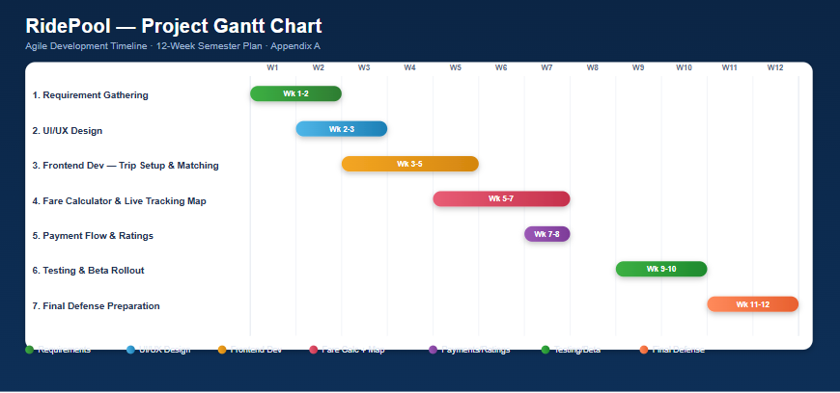

5. System Architecture and Design

Overall System Architecture Diagram
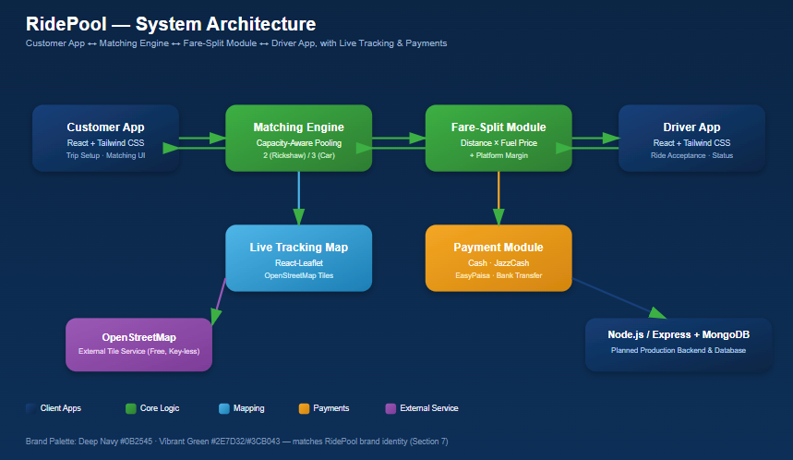

Technology Stack
Layer | Technology | Justification
Frontend | React (JavaScript) + Tailwind CSS | Enables rapid, component-based UI development with a consistent navy/green brand system and full responsiveness across devices.
Mapping | React-Leaflet + OpenStreetMap | Free, open-source, key-less mapping solution suitable for a student prototype without recurring API costs.
Backend (planned production) | Node.js / Express | Lightweight, JavaScript-consistent backend suitable for handling ride-matching and split-fare logic at scale.
Database (planned production) | MongoDB | Flexible schema suited to varied ride, passenger, and fare-split records.

6. UI/UX Design

User Experience Flow
The user journey is intentionally split across four sequential screens rather than a single dashboard, ensuring each step is digestible: (1) Home/Trip Setup — entering pickup and destination with autocomplete, selecting a vehicle type, and toggling distance units; (2) Ride Selection & Passenger Matching — viewing available pools and manually choosing whether to share with specific matched passengers, constrained by vehicle capacity; (3) Live Trip Tracking — viewing the active route on a live map alongside driver and co-passenger profiles; (4) Trip Completion & Payment — viewing the itemized fare-split receipt and selecting a localized payment method.

Responsiveness
All screens are built using Tailwind CSS responsive utility classes, ensuring the trip setup form, matching list, map view, and fare receipt adapt cleanly across desktop, tablet, and mobile breakpoints. [Insert side-by-side desktop/tablet/mobile screenshots here.]

Accessibility Considerations
The interface uses high-contrast navy-on-white and green-on-white color combinations to meet WCAG contrast guidelines, clear iconography paired with text labels (not icons alone), keyboard-navigable form fields for location entry, and tooltips on the fare-split breakdown explaining how each number was calculated.

7. Branding, Logo, and Pricing Strategy

Logo Design


Brand Identity
- Color Palette: Primary — Deep Navy (#0B2545); Secondary/Accent — Vibrant Green (#2E7D32 / #3CB043).
- Typography: Clean, modern sans-serif (e.g., Inter or Poppins) for headings and body text, reflecting a tech-forward, trustworthy brand.
- Brand Voice: Friendly, transparent, and practical — speaking directly to the everyday cost pressures faced by Pakistani commuters, without overpromising.

Pricing Model
Package | Features | Price | Target Segment
Basic | Standard ride matching, distance-based fare split, Cash payment only | Free (platform fee only on ride) | Students / occasional commuters
Premium | Priority matching, all payment methods (JazzCash, EasyPaisa, Bank Transfer), ride scheduling | PKR 99/month | Daily professional commuters
Enterprise | Corporate/university bulk ride coordination, dedicated support, usage analytics dashboard | Custom pricing | Universities & companies

Value Proposition
RidePool's value proposition is straightforward: pay only for the distance you actually travel, calculated transparently against the real-time fuel price, instead of bearing the full cost of a private ride or an opaque flat ride-hailing fare.

8. Market Analysis and Targeting

Target Market Profile
Attribute | Description
Demographics | Ages 18-40; university students and early-to-mid career professionals; middle-income; based in major Pakistani urban centers, primarily Lahore.
Psychographics | Cost-conscious, environmentally aware, comfortable with mobile apps and digital payments, values predictable daily routines (fixed commute routes).
Behavior | Currently relies on personal vehicles, rickshaws, or ride-hailing apps for fixed daily routes; price-sensitive due to repeated fuel price increases; open to sharing a ride with verified strangers if cost savings and safety are clear.

Competitor Analysis (SWOT)

Uber/Careem
Strengths: brand trust, wide coverage. Weaknesses: no transparent distance-based cost split for pooled rides. Opportunities: localize fare-split logic for Pakistan. Threats: established user base.

Yango
Strengths: competitive base pricing in Pakistan. Weaknesses: no peer-to-peer fare-splitting feature. Opportunities: RidePool can capture price-sensitive segments Yango doesn't directly serve. Threats: Yango could add similar features given scale.

InDrive/Bykea
Strengths: low-cost negotiable fares, strong local presence. Weaknesses: no structured multi-passenger split or mutual-rating trust system. Opportunities: RidePool differentiates through transparency and trust. Threats: low switching cost for users between apps.

9. Marketing and Sales Strategy

Customer Acquisition Channels
- Social Media: Instagram and TikTok focused on short demo videos of the fare-split calculator and real student testimonials of monthly savings; posting 3-4 times per week during launch phase.
- Digital Marketing: Campus-targeted social ads and local SEO content (e.g., 'cheapest way to commute in Lahore') ahead of broader SEM investment.
- Partnerships: Collaborations with university transport societies and student ambassadors, plus outreach to small fleet/rickshaw owners willing to list on the platform.

Sales Strategy
The sales funnel begins with free Basic-tier signups acquired through campus and social channels, converting price-sensitive daily commuters into Premium subscribers once they experience consistent monthly savings from the fare-split calculator. Revenue targets for Year 1 focus on subscription conversions from the existing free user base rather than aggressive paid acquisition, keeping customer acquisition cost low.

10. Social Engagement Milestones
Milestone | Target | Timeline | Status
Social Media Launch | Create accounts on 3 platforms | Week 1-2 | Pending
Initial Followers | 100 followers combined | Week 3-4 | Pending
Content Engagement | 10+ comments/shares per post | Week 5-6 | Pending
Community Feedback | Survey 50+ potential users | Week 7-8 | Pending
Beta User Signups | 25+ beta testers registered | Week 9-10 | Pending
Influencer/Partner Outreach | Contact 5 potential partners | Week 11-12 | Pending

Social Proof Evidence
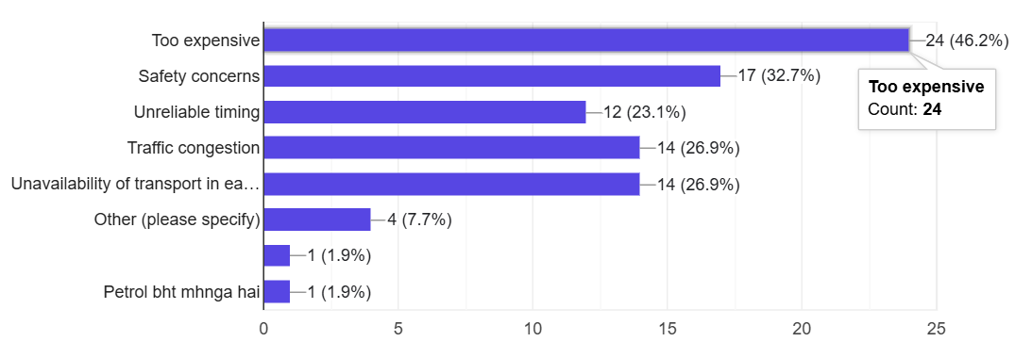

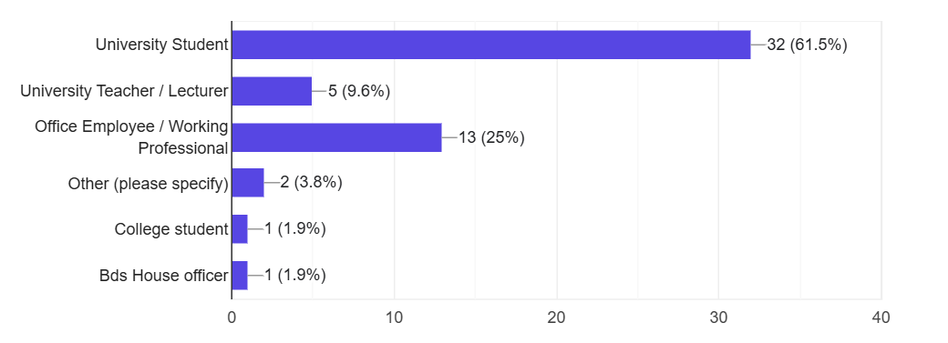

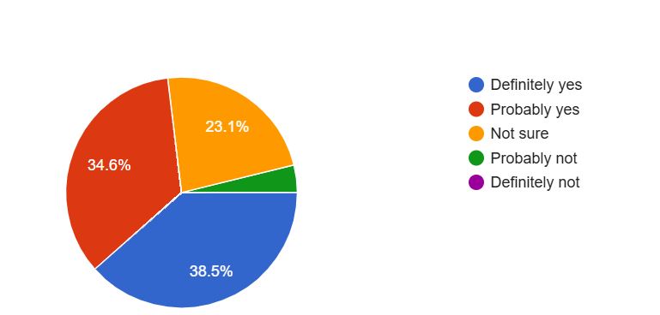

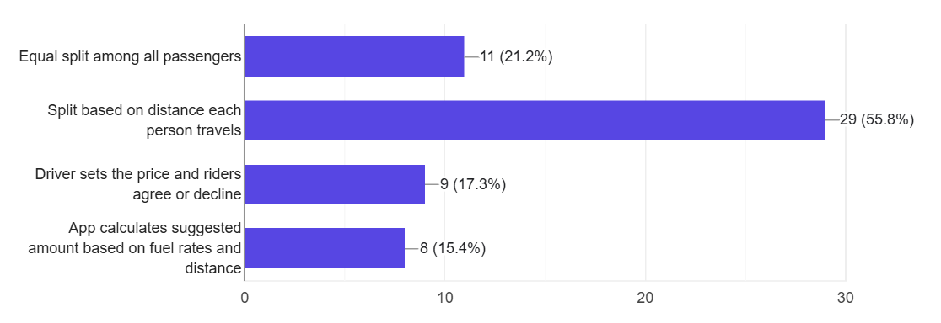
Community Building Strategy
RidePool will build its early community through campus ambassadors who organize small pilot pooling groups along common university-to-residential routes, supported by a feedback loop where beta users directly influence prioritization of Should-Have and Nice-to-Have features such as ride scheduling.

11. Operational and Management Plan

Day-to-Day Operations
Daily operations center on monitoring active ride matches, ensuring the fuel-price input remains updated against current market rates, reviewing driver/passenger ratings for trust and safety issues, and triaging customer support queries related to fare disputes or matching problems. Development continues in two-week Agile sprints with regular beta-user feedback reviews.

Team Structure
Role | Responsibilities | Team Member
Project Lead/CEO | Overall strategy, stakeholder communication, financial planning | Hoor UN Ain
Technical Lead | System architecture, fare-split algorithm, frontend/backend development | Areesha Raheel
Marketing Lead | Social media, campus partnerships, beta user acquisition | [Name]

12. Financial Plan

Startup Costs
Category | Amount (PKR)
Development/Technology | [Amount]
Marketing/Branding | [Amount]
Operations/Equipment | [Amount]
Contingency (10-15%) | [Amount]
TOTAL | [Total Amount]

Revenue Forecast (Year 1)
[Include monthly/quarterly revenue projections, assuming gradual conversion of free Basic users into Premium subscribers as cost-saving benefits are demonstrated through real usage of the fare-split calculator.]

Breakeven Analysis
[Calculate and explain expected breakeven point based on subscription revenue, platform fee per ride, and estimated operating costs.]

Funding Requirements
[State funding needed for initial development and marketing, and potential sources: bootstrapping, university incubator grants, or early-stage investors interested in mobility/fintech-adjacent solutions for Pakistan.]

13. Risk Analysis and Mitigation
Risk | Likelihood | Impact | Mitigation Strategy
Fuel Price Volatility | High | High | Keep fuel price field manually adjustable and prominently editable so fare calculations always reflect current market rates.
Technical Failure (Map/Calculator) | Medium | High | Use stable, free, open-source APIs (OpenStreetMap), thorough testing of the fare-split logic, and fallback static map view.
Market Competition | High | Medium | Differentiate clearly through transparent distance-based splitting and localized payment support, not just lower pricing.
Customer Acquisition | Medium | High | Multi-channel campus and social media marketing combined with ambassador-led community building.
Trust & Safety in Shared Rides | Medium | High | Mutual rating system for drivers and co-passengers, verified-user badges, and manual passenger-matching control.

14. Project Demonstration Summary

Key Features to Demonstrate
- Trip Setup screen with location autocomplete, vehicle type selection (Auto Rickshaw vs Car/Sedan), and distance unit toggle.
- Passenger matching screen showing capacity-constrained ride pools and manual share/no-share toggles.
- Live distance-based Fare Split Calculator showing total fuel cost, adjustable fuel price, platform fee, and per-passenger PKR share, alongside live trip tracking on an OpenStreetMap-based map.

Demo Environment
Local prototype running via React + Tailwind CSS (npm install / npm run dev on localhost:5173), with React-Leaflet + OpenStreetMap for live tracking. [Insert live deployment link if available.]

15. Appendices
- Appendix A: Gantt Chart / Project Timeline
- Appendix B: Complete UI/UX Mockups (Trip Setup, Matching, Tracking, Payment screens)
- Appendix C: Survey Results / User Research
- Appendix D: Social Engagement Screenshots
- Appendix E: Competitor Analysis Details (Uber, Yango, InDrive/Bykea)
- Appendix F: Financial Projections (Detailed)

